CPI 2020 Scores for Armenia and Other Countries of the Region

Armenia’s 2020 CPI score is 49 and its standard error – 3.50. Compared to last year it increased by 7 points and it is the second largest increase in the world after Maldives, whose CPI score inceased by 14 points compared to 2019 (from 29 to 43). For data used for the calculation of Armenia’s 2020 CPI see material “Corruption Perception Index 2020: Full Source Description”. Figure 1 presents Armenia’s CPI scores from 2012 to 2020.
Figure 1.
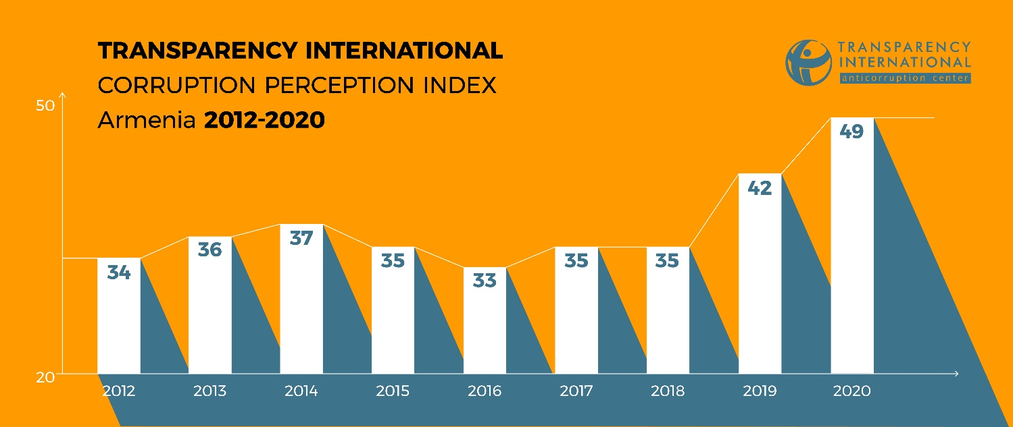

In the 2020 CPI ranking table Armenia together with Jordan and Slovakia shares 60-62 places among 180 countries (in 2019 with CPI score equal to 42 it was sharing 77-79 places among 180 countires).
According to Transparency International’s regional division, Armenia, as before, is included in the Eastern Europe – Central Asia region. Table 1 shows the 2020 CPI ranking table for that region.

Table 1.
Rank | Country | CPI score 2019 | CPI score 2019 | AFDB | BF (SGI) | BF (TI) | EIU | FH | GI | IMD | PERC | PRS | VDEM | WB | WEF | WJP
44 | Georgia | 56 | 5 |  |  | 53 |  | 50 | 47 |  |  |  | 68 |  |  | 61
66 | Belarus | 45 | 7 |  |  | 37 | 55 | 33 | 47 |  |  | 32 | 49 |  |  | 60
66 | Montenegro | 45 | 5 |  |  | 53 |  | 47 | 47 |  |  |  | 26 |  | 51
77 | Armenia | 42 | 6 |  |  | 45 |  | 39 | 47 |  |  | 32 | 32 |  | 60
91 | Serbia | 39 | 8 |  |  | 45 | 37 | 53 | 35 |  |  | 32 | 35 |  | 40 | 35
91 | Turkey | 39 | 9 |  | 26 | 37 | 37 |  | 47 | 45 |  | 41 | 25 |  | 57 | 38
101 | Bosnia and Herzegovina | 36 | 7 |  |  | 37 | 37 | 44 | 35 |  |  |  | 32 |  | 29 | 40
101 | Kosovo | 36 | 5 |  |  | 37 |  | 36 | 35 |  |  |  | 39 | 35
106 | Albania | 35 | 8 |  |  | 37 | 37 | 42 | 35 |  |  | 41 | 20 |  | 37 | 28
106 | North Macedonia | 35 | 7 |  |  | 41 | 20 | 47 | 35 |  |  |  | 28 |  | 32 | 42
113 | Kazakhstan | 34 | 9 |  |  | 33 | 20 | 24 | 35 | 55 |  | 43 | 17 |  | 47 | 36
120 | Moldova | 32 | 9 |  |  | 29 | 37 | 33 | 47 |  |  | 32 | 21 | 27 | 30 | 30
126 | Azerbaijan | 30 | 7 |  |  | 29 | 20 | 21 | 35 |  |  | 24 | 10 |  | 69
126 | Kyrgyzstan | 30 | 7 |  |  | 37 |  | 30 | 35 |  |  |  | 17 | 35 | 26 | 28
126 | Ukraine | 30 | 9 |  |  | 41 | 20 | 36 | 22 | 31 |  | 36 | 23 |  | 30 | 34
137 | Russia | 28 | 9 |  |  | 29 | 20 | 24 | 22 | 37 |  | 24 | 21 |  | 38 | 36
153 | Tajikistan | 25 | 6 |  |  | 17 |  | 21 | 22 |  |  |  | 13 | 18 | 57
153 | Uzbekistan | 25 | 7 |  |  | 29 | 20 | 21 | 22 |  |  |  | 22 | 27 |  | 35
165 | Turkmenistan | 19 | 5 |  |  | 17 | 20 | 21 | 22 |  |  |  | 15

As it can be seen from the Table, Armenia is on the 2nd place among 19 countries of the region (in 2019 it was on the 4th place). In the region Armenia lags only behind Georgia, whose 2020 CPI score is 56 (45-47th places in the world ranking).
As of Armenia’s neighbors, Armenia continues to be behind only from Georgia. Similar to 2019 is ahead of its three other neighbors - Turkey (86-91st places in the world ranking), Azerbaijan (129 -133th places) and Iran (149-156th places). Their 2020 CPI scores are 40, 30 and 25, respectively. Figure 2 presents the dynamics of Armenia’s and its neighbors’ CPI scores from 2012 to 2020.

Figure 2.
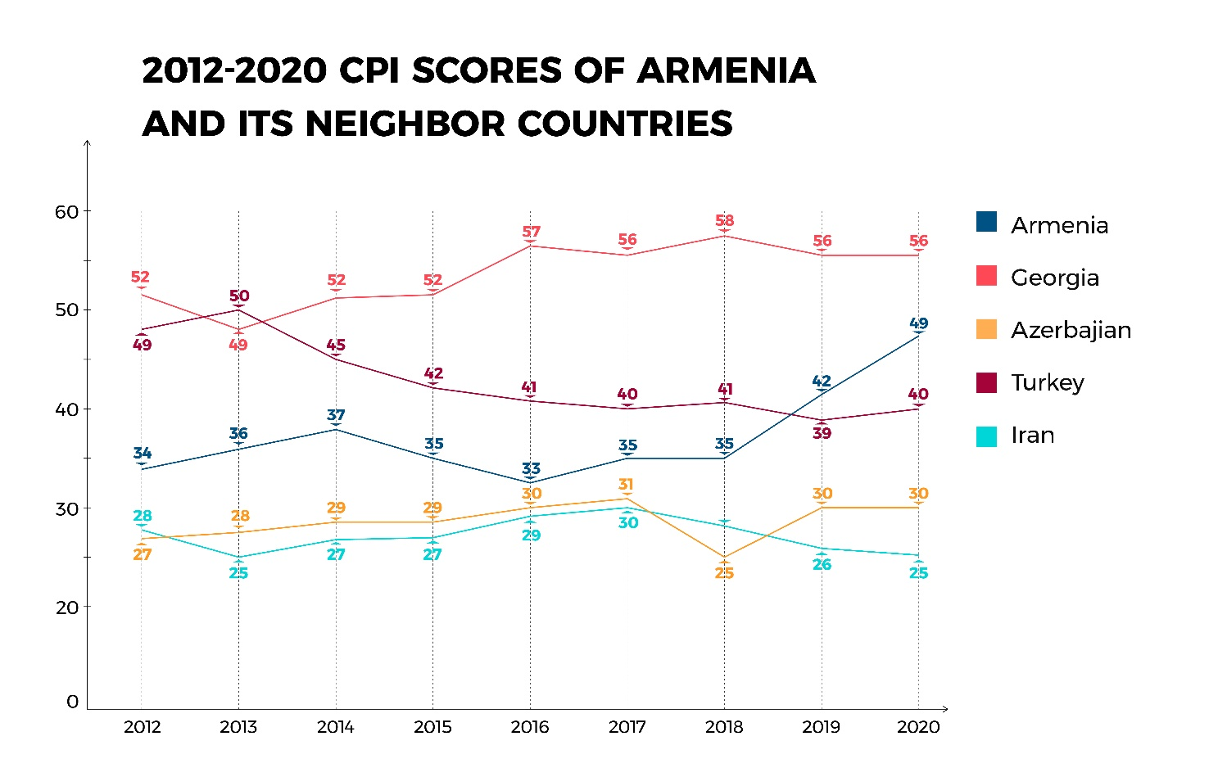
All member countries of the Eurasian Economic Union (EEU) score worse, than Armenia. In particular, Belarus’ 2020 CPI score is 47 (63-66th places), Russia’s – 30 (129-133th places), Kyrgyzstan’s – 31 (124-128th places) and Kazakhstan’s – 38 (94-101st places). Figure 3 shows the dynamics of Armenia’s and other EEU member states CPI scores from 2012 to 2020.

Figure 3.
