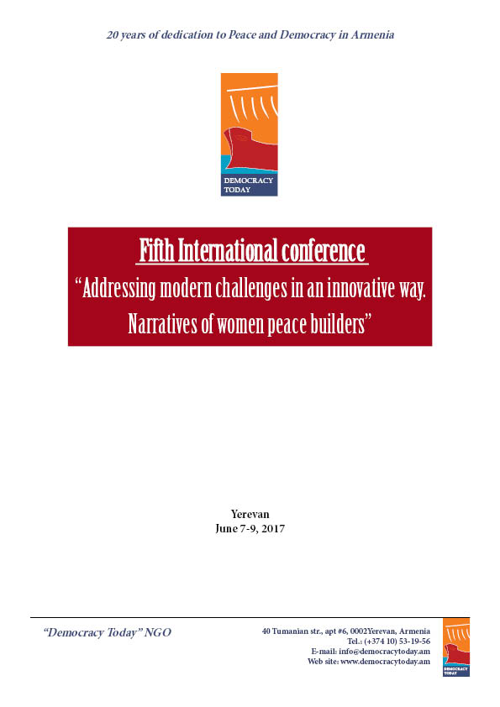
ABOUT THE CONFERENCE
This is the fourth annual conference organized by “Democracy Today” under the auspices “Women for peace and stability. Peace starts from your home” that will take place in Yerevan from September 7-9, 2016. The conference is an open platform bringing together government officials, international community, civic and religious leaders, activists and academics to speak and develop common policy approaches on issues that challenge women’s equal participation in formal peace processes and conflict transformation.
Every year the themes are chosen through discussions with women. Previous conferences covered the following themes: impact of religious fundamentalism on women’s rights, violence against women during war and rape as war tools and role of peace keepers and international community in bringing and sustaining peace, empowerment of women to take decisive roles in policy and peace building and constructive discussions and learning how to strengthen the implementation of UNSC Resolution 1325.These have been transforming conferences and are strongly result oriented. Every year the interest in the conference grows and we have more and more applicants.
The chosen theme for this year is “Addressing modern challenges in an innovative way. Narratives of women peace builders”.
We live in a world with strong political and economic incentives for violence. The nature of modern wars has been changing combining economic interests with geopolitical ambitions. Men with guns occupy peace tables where women peace builders do not even have an access to it; we still invest trillions in arms but spend only incomparably little for peace. Conflicts and wars become a profitable business and the only way to “solve” the ambitions of states. The traditional military objective of defeating an enemy is “replaced by combination of economically driven interests in continued fighting and the institutionalization of violence for what there is some clearly profitable level of intensity” with the end goal, for some wars, not to win the war but to make a profit from the instability created by the conflict. Consequently, the longer a conflict endures, the more money and resources these “war profiteers” accumulate. Waging war becomes profitable. Diplomacy, negotiations, people’s interests, human rights are yielding policies of war. Not very often we hear on peace agreements, rather daily information on wars, conflicts, terror and death of innocent people are on the news. In April 2016, the war broke out in Nagorno-Karabakh taking lives of many innocent people. Prior to that, during many years border communities of Armenia have been under heavy daily shelling resulting in human loss and destruction. In many parts of the world generations grow that have not seen any other life than war. Many were gripped by fear and anger; others learned to dull their feelings with a quality of silence that often follows a catastrophe.
The world situation, wars and growing instability worldwide, militarism and war economy and their impact on women are concerns that will be brought out during the discussions of the conference to be held in Yerevan.
Some alarming data provided in studies explains our concerns well:
•At least 1500 people are killed by armed conflicts and armed violence every day. Extra-judicial executions and excessive use of force by state security forces amount to over 500,000 per year or 1,500 per day.
• Systematic rape of women and girls occur through the use of weapons. In conflict regions such as the Democratic Republic of Congo, Cote d’Ivore, and Sierra Leone, Syria, Iraq, the scale of rape and sexual violence is staggeringly high. Many women and girls have been forced into sexual slavery by fighters, and many are raped at gunpoint. Women and girls are often the forgotten victims of armed conflicts.
• More than 30 million people have been forced to flee their homes. Millions of people have been forced to flee their homes for fear of their lives due to armed conflict. This often pushes people further into poverty by restricting the access to clean water and shelter, while increasing the likelihood of deadly diseases.
• Child soldiers are being used in armed conflicts in 19 countries.
Tens of thousands of children are being used right now by governments in their armed forces and by non-state armed groups. These children are often armed using weapons irresponsibly traded by governments and private corporations.
• For every death, there’s up to 28 serious injuries. It’s difficult to estimate exactly how many people are injured in armed conflicts. Past statistics indicate that as many as 28 people are injured for every person killed by weapons on battlefields.
• Damage caused by weapons destroys infrastructure and perpetuates poverty. Besides killing and harming people, weapons such as missiles destroy vital infrastructure that people rely on in their daily lives - such as access to food, water and shelter. This pushes countries into poverty.
This is the reality. But there is also another reality – strong antiwar movement, growing understanding that peace is everybody’s right. It is an inclusive process and cannot be solved only by a group of people. There is the realization that peace can be achieved only with equal participation of women at the peace table and new understanding of economy - peace economy that is contrary to war economy. Women have long term capacity in peace processes and negotiations, their presence in peace table is critically important at the state of the world.
The conference will provide different opportunities to present the views; panel discussions, presentations from the audience, working groups and side events.
We are very privileged that this year women from different conflict areas expressed interest to participate in the work of the conference. We will use this unique opportunity to learn from them about the situations in countries such as Ukraine, Iraq, Columbia, Cyprus, Afghanistan, Syria, Georgia, Nagorno-Karabakh during special side events and discuss with them the tools they use to advance women in peace processes.

BACKGROUND
Modern history of Caucasus, ethnically extremely diverse region, that makes home for more than 50 ethnicities, has been marked with search for identity in the new social and economic environment and political tensions and conflicts.
The conflicts and wars that embarked in the region during the last two decades created numerous obstacles, ceasefire zones, brought to reshaping the concept of unity that was called earlier Caucasus, limiting opportunities for interrelation between the states and people and possibilities of integrated common regional vision for joint development.
Women in the Caucasus, who have historically played important role in peace making and society building and reconciliation, seem to be invisible in these processes. There has been common interest raised at the civil society level for the need of innovative approaches to rethink the situation and need for common endeavor to work together to build and integrated common home. It is necessary to have larger vision for the region to provide hope, inclusive progress and development. It is important to increase opportunities for direct contacts and better knowing and understanding each other to develop wider vision and sustainable peace. Women had and have important role in building peace and education of their societies, their important activities have to be supported and joined programs supporting, empowering women have to be developed. The aim of the first meeting organized by NGO from Armenia “Democracy Today” (in cooperation with partner organizations from Azerbaijan and Georgia, founding members of initiative “Women of South Caucasus for Peace and Security in the region”) is to develop new platform of cooperation, will bring to collaboration women’s groups from entire Caucasus and create network of women peace makers, the network they will learn from each other, the network they will support and get empowerment.

Deadline: April 10, 2017.
Contacts: Anna Ishkhanyan, Gulnara Shahinian, Lusine Torosyan
Address: 40 Toumanian str., apt 6, 0002 Yerevan, Armenia
Tel.: + (374 10) 531956; + (374 77) 41 45 18; +(37477) 87 98 61; + (374 77) 56 55 80
Email: info@democracytoday.am; anna.ishkhanyan@gmail.com; gulnara.shahinian@gmail.com; lusine.torosian@gmail.com
APPLICATION FORM
“ADDRESSING MODERN CHALLENGES IN AN INNOVATIVE WAY. NARRATIVES OF WOMEN PEACE BUILDERS”

FIFTH INTERNATIONAL CONFERENCE
YEREVAN, ARMENIA, JUNE 2017

*1. Name of organization/individual:
*2. Contacts
*Address:
*Telephone number:
Fax number:
*E-mail:
*3. Goals of organization/activities:
*4. Developed in the last five years projects/activities:
*5. Interest in participation:
*6. Mode of presentation:
*7. Required equipment:
*8. Name and position of person who will participate:

