The Mobility Fund for CSO Experts in the Black Sea Region

- reimbursement FORM -

The filled in and signed reimbursement form must be sent together with the supporting fiscal documents (invoices/ fiscal receipts, proofs of payments etc) scanned by e-mail at the address: fond.romania@gmail.com and the original documents must be sent by post at following the address: FOND Romania, Calea 13 Septembrie, no. 85, Bl. 77C, ap. 74, et. 8, postal code 050713, Bucharest, Sector 5, Romania.
The reimbursement of expenses will be made by bank transfer in maximum 15 days from the confirmation receipt of the complete reimbursement request (containing all of the original documents above mentioned).
The incomplete reimbursement requests or those which do not respect the deadline will not be taken into consideration and the applicant will lose the financial support awarded following the submission of the application!

Information about the applicant*:

First name:

Last name (family name):

Contact data (telephone, e-mail, address):

Organization & Position:

Website:

Activity (title, date, place):
* The personal data provided in the above-mentioned section will be stored and processed by the Romanian NGDO Platform – FOND only for reimbursement and reporting purposes, in accordance with the General Data Protection Regulation (GDPR) 2016/679.
FOND Romania will share any given personal data with the members of the project team, the donor, as well as any potential external auditor.

Bank data for reimbursement (EUR/ RON accounts only):

Name of account holder:

IBAN:

BIC/SWIFT:

Bank / Branch:

Bank address:

Expenses requested for reimbursement:

No. | Expense description | Expenses in national currency | Exchange rate** | Expenses in EUR
 | TOTAL

** The exchange rate national currency - EUR will be calculated using the official exchange rate of the National Bank of Romania. The exchange rate will be filled in by FOND.

DOCUMENTS TO ATTACH:
(without these documents, the reimbursement form will not be taken into consideration):

- Supporting fiscal documents (invoices/ fiscal receipts, proofs of payments, flight tickets and boarding passes – for travel by plane, train tickets – for travel by train, roadmap with no. of kilometres and distances – for travel by car, accommodation vouchers, receipts for meals/ local transport, bus/ tram/ metro tickets etc.) corresponding to the expenses requested for reimbursement;
- Activity report (Annex I of the Reimbursement Form).

SIGNATURE OF THE APPLICANT*** ______________________________

DATE ____________________________________________________

*** By signing this application form to The Mobility Fund for CSO Experts in the Black Sea Region, the applicant takes full responsibility for respecting the funding conditions mentioned in the document “Mobility Fund – Funding Guidelines”, as well as give his/ hers consent to FOND for storing and processing the data provided as mentioned above.

______________________
This activity is part of the project „Building CSO Capacity for Regional Cooperation within the Black Sea Region”, implemented by the Romanian NGDO Platform – FOND and funded by the European Union for the next three years, for the period January 2019 – December 2021.
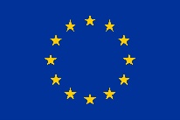
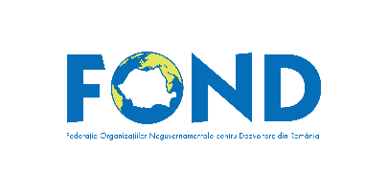

ANNEX 1. ACTIVITY REPORT

First name:

Last name:

Organization & Position:

Activity (title, date, place):

Applicant’s contribution:

Results of the activity:

Relevance for the consolidation of regional cooperation within the Black Sea Region:
Planned follow-up (sustainability/ multiplication) and potential coordination with the Black Sea NGO Forum:
Visibility & communication (links to materials issued from the applicant’s participation, website articles, social media posts, photos taken during the event etc)

Recommendations for the improvement of the Mobility Fund (priorities, implementation procedures, financing procedures etc):

______________________
This activity is part of the project „Building CSO Capacity for Regional Cooperation within the Black Sea Region” is implemented by the Romanian NGDO Platform – FOND and funded by the European Union for the next three years, for the period January 2019 – December 2021.

